Review questions

1.1 What is meant by the term 'project management'?

1.2 How does project management differ from project leadership?

1.3 What are the four variables/constraints forming the initial project boundary?

1.4 How do methodologies assist in the planning and management of projects?

1.5 What are the benefits in following a life-cycle approach to project management?

### Definition

Project: is a temporary endeavour to create a unique product, service or result, collection of activities and tasks to achieve a specific but temporary goal of the organization, with specific performance or quality requirements

Management: application of knowledge, ski3ll, tools, technique to meet project requirement; initiating, planning, executing, monitoring and controlling, and closing 5 STAGES, management of project activities lead to successful completion project

Manager pressure best result

key management principles: planning, organizing resources, leading resources and controlling

### Sustainability

Definition: Meet the need without damage future people meet their need.

THINK LONG TERM IS REALLY IMPORTANT, DONT THINK PROFIT ONLY

consumption with the meaning with purpose

Company got goals by integrating economic, environmental & social opportunities into its business strategies = Triple Bottom Line (TBL) approach

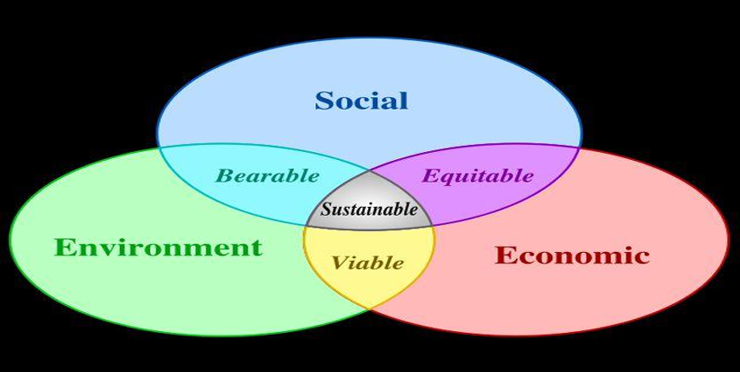

* Economic - financial health, economic performance, return on investment (ROI), return on assets (ROA)
* Environmental - mineral & energy resources, air, water & land resources
* Social – HR, stakeholder

### Product (not project) Life cycle vs Design

Way to extend life: Reliability, Reparability (to environment), Upgradability, Variability, Attachment  
(变异性: 指产品提供不同功能或体验以满足不同客户偏好或需求的能力, Google Project Ara，它旨在允许用户定制和升级其智能手机的单个组件（如相机，电池或内存），而无需更换整个设备。

依恋: 用户与产品形成的情感或心理纽带有关。增强依恋意味着设计用户对产品产生喜爱或忠诚感。Eg: 产生共鸣的品牌)

No technologically complex, and can fit in with existing project（设计时应考虑到简单性和兼容性，使其易于使用并与消费者已经拥有的现有系统或产品集成）

Highly visible & communicable （优点或功能应该对用户来说一目了然）

Offer recognisable advantages （与竞争产品相比，产品应具有明显和显着的优势）

### Why Design important?

70% of cost save in this part; impact number of resource/waste; source of innovation/potential competitive advantage; Pressure to adhere from multiple sources (i.e. Governments, lobby groups, etc.).

Other Potential: Saving labor resource energy; positive image; Intellectual property (IP) & long-term returns; In TBL

### Lifecycle impact

Impact is positive/negative result in product/process/activity of project; social/economic/environmental/ of society.

* Negative: resource/health/safe/quality of life/economic/society

Examle:

characteristics of project

* Unique…
* Timeframe (S/F)…
* Stakeholders including client/sponsor…
* Sequence and deliverables…
* Team effort...
* Quality…
* Schedule…
* Budget…
* Complexity...
* Risk…
* Contracts

Project Management lifecycle

1. Concept – initiation: goals/deliverable/strategic/raised problem/method research/ TBL and life cycle
2. Planning – schedule: preparation, assign resource, schedule based on last stage
3. Execution & monitor & control: do the planning and monitoring where schedule need to improve/update. The project has commenced tracking actual progress using the schedules.
4. Finalization – evaluation: project completed and deliverable to client, evaluated and report written presented to admin

Benefit project management lifecycle

* Detail responsibility.
* Label milestone/deliverable/decision
* Identify control gate
* Prescribes manageable portions

Benefit of successful PM improve accountability/ scope definition (costly if we turn back adjust the scope)/ efficiency/ performance management/ consistency/ transparency

REMEMBER PART Project life cycle inputs

REMEMBER PART Project life cycle outputs

four variables/constraints forming the initial project boundary: time/cost/scope/resources

### REMEMBER PART Failure causes

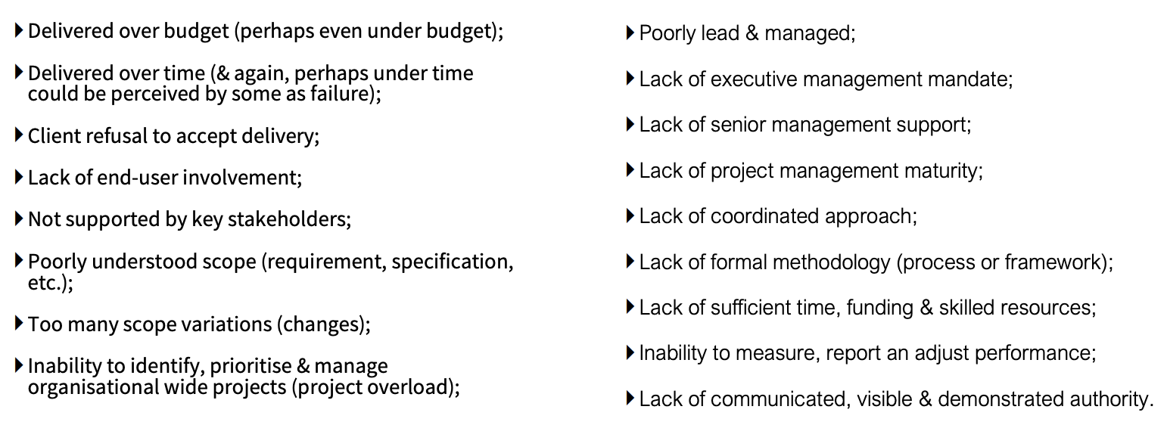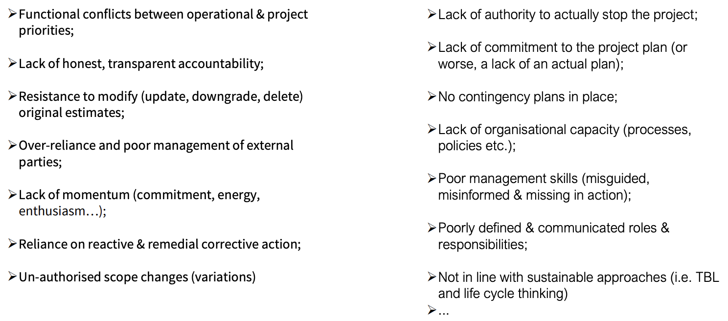

### REMEMBER PART Indicators of project success

Answer:

* Project management is the application of knowledge, skills, tools, and techniques to project activities to meet the project requirements. It involves a series of processes and activities such as initiating, planning, executing, monitoring, controlling, and closing projects, all aimed at achieving specific objectives within defined constraints like time, quality, and budget.
* Project management primarily focuses on the execution of project processes and the achievement of objectives within operational constraints, using formal methodologies and tools. Project leadership, on the other hand, involves guiding and motivating the project team, influencing and inspiring stakeholders, and effectively managing change and challenges throughout the project life cycle
* scope, time, cost, and quality. These elements are interrelated; any change in one often impacts the others. Scope defines what will be delivered, time specifies the schedule for delivery, cost involves the budgetary limitations, and quality dictates the standards
* Methodologies provide a structured approach to planning and managing projects. They offer frameworks, techniques, and tools that help project managers and teams organize their work, manage resources, mitigate risks, and achieve consistency in processes
  + Structured Phasing: Helps in organizing project work into manageable stages, allowing for better control and more systematic execution.
  + Improved Risk Management: Enables early identification and mitigation of risks through systematic reviews at each phase.
  + Enhanced Planning: Facilitates thorough planning before beginning the work and detailed planning for subsequent phases as the project progresses.
  + Resource Efficiency: Allows for better allocation and optimization of resources throughout the project.
  + Stakeholder Engagement: Provides multiple opportunities for stakeholder involvement and feedback, which can help align the project more closely with user needs and expectations.
  + Quality Control: Through phase gates and reviews, the life-cycle approach ensures that the project meets the required quality standards and conforms to the defined scope.